A Multicultural Approach to Teach Sustainability

Nídia Caetano^{1,2}, João Rocha³, José Carlos Quadrado³, José Marílio Cardoso³ and Manuel Carlos Felgueiras¹
¹CIETI/ISEP/IPP - Center for Innovation in Engineering and Technology, School of Engineering, Polytechnic Institute of Porto
²LEPABE/FEUP - Laboratory for Process Engineering, Environment, Biotechnology and Energy, Faculty of Engineering, University of Porto
³ ISEP/IPP - School of Engineering, Polytechnic Institute of Porto
Portugal
nsc@isep.ipp.pt, jsr@isep.ipp.pt, jcq@isep.ipp.pt, joc@isep.ipp.pt, mcf@isep.ipp.pt

Abstract
Globalization is a trend that covers all society perspectives in general, and higher education in particular. The main traditional objective of higher education institutions has been to prepare domestic students with a given set of skills. Research competition and University’s rankings, as well as the need to reach other publics, pushed them towards internationalization. The exchange of students across the EU is a well-known reality which success is largely due to cultural similarities. However, a set of issues raises in importance when students from different cultures are involved. ISEP proposed a Summer Course aiming both to increase its level of internationalization and to verify how the institution is able to host foreign students. Therefore was organized, in July 2014, ISEP’s first Engineering for Sustainable Development Summer Course, with a layout specifically designed to address those questions. In our study, and in order to gain from an intensive and multicultural experience, the class included equal number of Korean and Portuguese students to develop work under the framework of sustainability, a theme chosen in order to foster consensus. This work reports some results from this experience, which included a Problem Based Learning (PBL) approach, and points out new directions: PBL revealed to be a promoting integration way; the inclusion of multiple cultures allowed the analysis of different perspectives which otherwise would not have been succeed; institutional academic/social services need to be adapted in order to receive non-Portuguese speaking students; there is a need for further adequate accommodation able to receive a larger number of international students.
Keywords: Multiculturality, problem based learning, summer course, sustainability.

INTRODUCTION
The School of Engineering (ISEP) of the Polytechnic Institute of Porto (IPP) is pursuing a major objective of gaining an important role at an international level. This can be done both by involving its academic staff in international R&D projects, participation in international conferences and congresses, developing joint educational programs and, at a student’s level, by the participation of students in different kind of mobility programs.
Erasmus Programs allow participation of students in learning activities in a formal level, therefore integrated in several courses currently taught, usually within the framework of their academic studies, during the class period. The number of international exchange students in the ERASMUS program remained approximately constant until 2007. From this year on, the number raised with a high rate [], making this scenario something that all high education institutions must considerer very seriously. This is only a single one feature from a complex set that is presently involving generically the way how universities will be teaching (Ferreira, 2015). Focusing only on the students’ exchange, a very short number of single students travel from Portugal to other European countries and in the opposite direction it occurs at slightly higher rates. During 2012/13 academic year, in Portugal, the global number of Erasmus Out students was 7041 whereas that of Erasmus In was 9894 (European Commission, 2014). In the case of ISEP, only 53 out of 6459 students went abroad to European institutions while 100 from European countries were received in 2012/13 (ISEP, 2014). The pointed associated reasons are mainly economic and linguistic. The first is directly related to the student’s economic limitations to support their own in a foreign country where the cost of living is higher than that in Portugal, but the second is linked to their difficulties or fear of attending courses in English or any other non-native language.
Portuguese students that go abroad try to find Universities providing courses taught in English (the Portuguese second language), and when that is not possible at all, they dare to attend classes in the foreign language. In such cases, assessment is often taken in non-previously learned language, which is responsible for poor results. However, in their own opinion, they acquired other very important soft-skills that made them stand-out from the rest of the students (ISEP-DEI, 2014).
In most of the cases, incoming students have to adapt their own to the course conditions, as Portuguese courses are often only taught in Portuguese. However, it is possible to have support learning materials in English language and/or extra private classes. Besides this, Portugal is well known for its offer of Erasmus Intensive Portuguese Language Courses, belonging to the Top Hosting Countries (European Commission, 2014). For formal courses, evaluation of foreign students has to be adapted either by providing the English version of their examination or by allowing them to prepare and present some curricular work, a common practice at ISEP.
Further, ISEP has tried to intensify internationalization, by also promoting the ISEP International Week, a whole week devoted to a particular theme, in which international professors and engineering professionals participate in Seminars taught in English. Each Seminar is specifically addressed to engineering graduation and/or post-graduation courses, and is mandatory for that course.
The 3rd ISEP International Week was devoted to renewable energy, recycling and sustainable development, a topic that is becoming extremely important in the modern world and particularly for engineers.
Knowing that the engineering labour market is international and also that all the students can enrich their curricula from an international experience, ISEP proposed and organized a Summer Course in Engineering for Sustainable Development (E4SD). The course main objectives was as follows:
1 – To organize a Summer Course very strong at an International level, to evaluate at what extent the School (teachers, students and staff) can deal with this new situation; to find out cultures much different from the European one;
2 – To study a theme that is easily understood and commonly accepted: Sustainability;
3 – To discuss a set of questions/problems using the PBL approach, as a means to find the best acceptable solution.
In the following sections it will be presented the format and curricula of the E4SD Summer Course, and also the different main aspects that made it stand out in the educational offer of ISEP.

THE E4SD FORMAT AND CURRICULA
Engineering is the application of scientific, economic, social, and practical knowledge with the objective of inventing, designing, building, maintaining, studying, and developing structures, machines, devices, systems, materials and processes (Encyclopædia Britannica, 2015). Teaching engineering in a conventional way is hard. Besides, there are many soft skills that must be developed by future engineering practitioners and that need different teaching approaches to be conveniently learned.
This processes is dynamic and includes several interconnected stages as depicted in Figure 1.
Figure 1. Engineering teaching/education process.
The early stage was the Educational to Technological. The main concern was to teach students the necessary skills in order to prepare them for the technological advances (e.g. ITC). Later stage was the Technological to Educational. In this stage the main concern was to reuse the technological advances to serve teaching activities (e.g. e-learning, remote labs, long distance teaching, blend teaching, etc.). The most challenging now is to include both efficiently in a Multicultural Scenario, where students with a diversity of cultures are included, and that was the primary objective on this Summer Course.
The E4SD Summer Course (later on referred only as E4SD) was planned to receive a maximum of 20 students, being half international and the remaining Portuguese, from different specialized fields of engineering or sciences. It was intended to provide education in the sustainability aspects of the engineering professional activity.
Sustainability, the ability of providing goods and comfort without compromising the future generations (World Commission on Environment and Development, 1987), is becoming a transversal requirement for the soft skills of ISEP students, either at a formal or an informal level. It is through the education of a distinguished kind of professionals that our society can evolve to an inclusive and fairer one, more concerned and compromised to a development that will not endanger the quality of life and the future of next generations (Buckler and Creech, 2014).
Although the concept of sustainability is perfectly established, several approaches have been used to introduce sustainability in the curricula of higher education courses with different results (Green, 2013; Labodová et al., 2014; Rose at al., 2015, Staniškis & Katiliūtė, 2015). Thus, having in mind that the E4SD course was designed for students from different engineering and non-engineering graduation courses, it had to respect the natural diversity of student’s knowledge.
Being a Summer Course it was programmed to include classes followed by a set of team work sessions where, in a PBL approach, students could develop and apply their new knowledge to a particular case study, within a period of two weeks. It was intended that students could learn in a friendly and open environment, therefore the E4SD also included social activities, leaving room for the foreign students to discover Porto, the host city, its traditions and singularities, with the supporting company of the Portuguese students.

E4SD Students
The international students came from different fields of engineering from several universities in South Korea and the E4SD was offered them as a prize for their results in the graduation course. Their ages ranged from 20 to 25 years old. The Korean students arrived to Porto two to three days before the first day of the course and, for courtesy they were received by at least one Portuguese teacher that was responsible for transporting them to the student’s residence where they would be staying for the two weeks of the Course.
In what concerns the Portuguese students it was demanded that they did not have examinations during the Summer Course period and that they were either finishing the graduation or the Master degree. Their ages were from 23 to 31 years old – at ISEP Master Courses’ timetable is Monday to Friday, from 18h10 to 23h20, what allows that students work simultaneously.
In Portugal most of the engineering students are male and, in spite of this, it was intended to keep equality of gender as most as possible. The final group included 5 female and 3 male from Korea, 5 female and 3 male from Portugal. These students were organized in groups of 4, from different fields of engineering, being 2 from Portugal and 2 from Korea.
It was mandatory that students were able to communicate, both at a written and an oral level, in English language, which was the first challenge for Portuguese students.

Accommodation
The Korean students were accommodated in a students’ residence from the Academic/Social Services of IPP, located at 5 min walking distance from ISEP. This was only possible due to the direct intervention of the vice-president of ISEP, and because fortunately in this period, part of the students had already returned home, after finishing their examinations.
Male and female students were housed in separate rooms in different flats of the same residence. The residence had all the household appliances needed for cooking, washing clothes, etc.

Course professors and collaborators
The Professors team chosen for teaching the Course Modules and Collaborators for supporting the PBL sessions was defined previously to the start of the course. Nevertheless, after its start it was necessary to make some adjustments, as some of the Professors had to be replaced by other colleagues with short notice. A total of 11 teachers, of which 2 came from the ISEL (School of Engineering) of the Polytechnic Institute of Lisbon (IPL) and 3 more collaborators, included the team.
From these teachers, 3 were directly involved in the organization, therefore accompanied almost all the activities. Also 2 more teachers from other Higher Education Schools were invited to integrate the Jury to evaluate the group work.
The secretariat of the E4SD was mainly supported by the vice-president’s secretary, the external Relations Office and the Course Coordinator.
Some of the course professors and collaborators volunteered and were responsible for receiving the Korean students at the airport/train station, and driving them to the accommodation place, in order to assure that the students were properly welcome.

E4SD Course planning
An informal welcome reception was prepared for the Saturday afternoon before the start of the course. This allowed to briefly present the supporting team of ISEP collaborators during the stay in Porto, the ISEP facilities and the course structure and schedule.
E4SD comprised classes of a formal type, for each of the ten modules: Engineering for a Sustainable Society, Decision Analysis for Sustainability, Innovation and Technology, Sustainability in Project Management, Risk Analysis, Ethics and Public Policy in a Global Society, Sustainable Product Design, Materials and Process for Sustainable Engineering, Renewable Energy, Team Work and Multilevel Perspective. These classes, from Monday to Friday, took approximately 5 working mornings, from 8h10 to 13h, with a coffee break.
Four morning periods (8h10 to 13h) were used for studying a problem in a PBL (Wood, 2003) approach and a final morning session was devoted to the presentation and discussion of the work developed by each group of students.
The choice for the PBL model allows that students learn by doing: they identify and discuss the proposed sustainability problem. The PBL approach enables students to build cognitive and metacognitive skills for acquiring, analysing, and applying knowledge. Further, by developing their projects, students learn important professional skills, such as collaborative work (how to manage interdisciplinary problems), gathering information (how to deal with uncertain and incomplete information), and how to communicate effectively through oral and written presentations (Steinemann, 2003).
As a means of improving the English language skills, helping the preparation the presentation of the group work, and developing the Korean and Portuguese language skills of all the students, it was also provided a set of English classes in 4 periods in the afternoon (from 15 h to 17 h).
The course plan also included a visit with students to the downtown area (in the first Monday afternoon), in order to present the most historical part of the city, the area that was under rehabilitation, while strengthening the bonds between students and Professors. There was a visit to the ISEP Museum (in the first Thursday afternoon).
Finally, the last day of the course included the presentation of the group work, an informal lunch and the Graduation and Farewell ceremony.

E4SD Case study for PBL
The base problem to be addressed by students under the PBL approach was The Rehabilitation of Historic Cities - The Case of Porto UNESCO World Heritage Site: A Sustainable Development Challenge.
Framed by this theme, each group chose one particular question to be the object of their study, and to prepare a presentation of their main conclusions about it. The questions addressed by the students are listed in Table 1.

Table 1. PBL Themes for group work
Considering the case of Porto as a basis to your work but keeping in mind a global approach to historical cities and their metropolitan areas, choose one of the following subjects to address the problem and contribute to the development of sustainable solutions:
Strategic approach to the rehabilitation of historical cities +
Evaluating the relevance of the built heritage and individual decisions of rehabilitating/rebuilding in a sustainable approach;
- Addressing transportation/mobility needs and standards in historical cities;
- How to make rehabilitation work for people and develop the economy?
- Modern infrastructure networks in historical cities - can we create historical smart cities?
- Are historical cities compatible with modern high education and research needs?

TEACHING ENVIRONMENTS
Teaching sustainability subjects includes not only the formal classes, but also all the other activities that are used by the students to learn under multicultural environments. Therefore, some aspects are: Formal classes in an informal scenario; Course materials; Discovering the City of Porto Heritage; Visiting ISEP Museum and E&O and Other social non-planned activities. Besides this, under the sustainability scenario, it was decided to have a lunch (Picnic) in ISEP garden. The last event was the Graduation a ceremony and closing session. Each of this topics will be explained in detail in the following sections.

Formal classes in an informal scenario
Being a Summer Course, it is important that students can learn in a more relaxing way. The course should be intended as a prize not as a punishment, and with classes starting early in the morning, and with students still suffering from jet lag, it was very important that the teachers could promote this informal learning environment.
The Korean and Portuguese cultures are quite different. In the first day of classes it was noticed that Korean students profoundly respect their teachers, which prevents them from direct interaction. The teacher of the first Module could promote the interaction, directly asking the students their opinion about some themes of Engineering for a Sustainable Society. The Portuguese students had an important role in this ice breakage, as they were very participative and are used to take an active part on their learning.
The first official ice breakage was promoted during the morning coffee break (15 min), when coffee and cookies were provided in an informal scenario, where teachers and students could speak freely and rest from the first morning period. Most of the Korean students had come to classes without having breakfast, therefore the coffee and cookies were provided thereafter from the first hour of the morning class, and students were encouraged to eat something before or even during the first morning class (5 min breaks).

Course materials
The E4SD supporting materials were made available for the students in a web page of the Moodle of ISEP. It consisted of Powerpoint slides, videos, as well as a list of references (e.g. websites) where various information on sustainability could be found.
It was our intention to dematerialize information as much as possible, and for so no materials were delivered in paper. A classroom equipped with a whiteboard, a datashow and 20 PC’s connected to the WEB was provided for the students for the whole period of the course.

Discovering the Porto Heritage
Contrary to Seoul, Porto is an ancient town, where old buildings and constructions live together with modern ones. The city has a history of many centuries, which rendered it the recognition as World Heritage from the UNESCO (United Nations Educational, Scientific and Cultural Organization). Therefore, in the spirit of holydays period and intercultural mix, the Portuguese students showed downtown to the Korean students, including some of the most singular buildings of the historical Porto, the area where rehabilitation was taking place, as well as some part of the already rehabilitated areas.
The São Francisco church and the Palácio da Bolsa, the São Bento train station, the Lello book shop, the Clérigos Tower (Figure 2) were a few of the places where the students could go and appreciate the architecture.
To finish the afternoon and to taste one of the Porto delicacies, we stopped at the Leitaria da Quinta do Paço (Figure 3), where everyone could taste the famous natas and drink the Super Bock beer, a tea or a juice.
After this, everyone was allowed to go back home and to rest on their own.
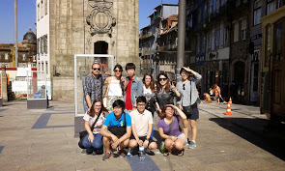
Figure 2. E4SD: Short break in front of the Clérigos Tower.
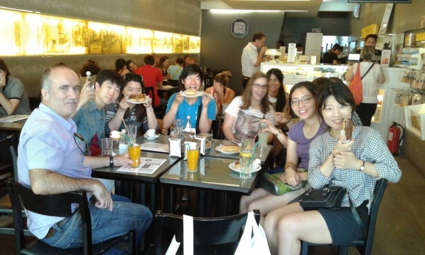
Figure 3. E4SD: Having a snack at the Leitaria da Quinta do Paço.

Visiting ISEP Museum and E&O
One of the sustainability pillars is the Social environment and commitment, therefore it was organized a visit to ISEP Museum and to the Engenho & Obra (E&O) site (a non-governmental organization for the development, acting in the area of social intervention).
ISEP Museum was chosen because our School has more than 160 years of history, being one of the eldest engineering schools in the country, and therefore the assets from years of practice of teaching in different fields of engineering has been preserved and made available to the community.
The main feedback of the Korean students was that the Museum had very ancient pieces but this did not represent much for them. Probably due to their short history in Seoul, they were more attracted to new technologies.

Other social non planned activities
The E4SD organization recommended the Portuguese students to integrate the Korean students, as much as possible, in the national culture. Therefore the Portuguese decided to take the Korean students to have the traditional Francesinha, they cooked Portuguese food in the only Républica that exists in Porto and where one of the Portuguese students lived. Finally they went to watch an important football match in the Dragão stadium.
All this interaction was possible because the Portuguese students were very dynamic, 4 of them coming from the same MSc course in Chemical Engineering, one in each working group. Also one of the Portuguese students had her birthday during the course, therefore there was birthday cake and singing to celebrate it.
As recognition of this informal environment and showing the change of attitude towards the teachers, the Korean students have decided to invite all their Portuguese colleagues as well as Professors to try a little taste of Korean food, cooked by themselves in their own residence. The result (shown in Figure 4) was a very nice evening, with very nice Korean food being served in the backyard of the students’ residence, lots of fun and party.
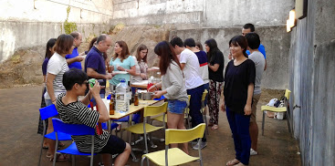
Figure 4. E4SD: Korean dinner in the students residence.

Picnic
A social event is usually included in every activity. The conventional format is a lunch served in one of ISEP’s restaurants. But this Summer Course was a singular event, devoted to Sustainability and Young Engineering students. Therefore, it was decided to organize a picnic to enhance the students’ integration in the ISEP community.
The picnic took place in the last day of classes, in the lawn area located near by the place where CIETI and GECAD Research Groups are installed. The nice green area has some trees to provide the needed shade and has easy access to ISEP community (Figure 5). All of the teachers involved in the E4SD, Academic staff with management responsibilities in the school, the President and its vice-presidents team, the international relations team, and everyone that was passing by was invited and had lunch together.
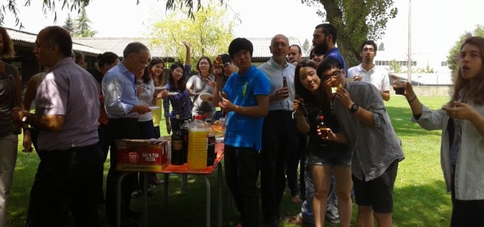
Figure 5. E4SD: Farewell picnic.

Graduation ceremony and closing session
The Graduation Ceremony took place in the Sala de Atos of ISEP and was divided in two parts. During the first part, more formal, the Vice-President Maria Joana Sampaio handed the certificates of participation in the E4SD (Figure 6).
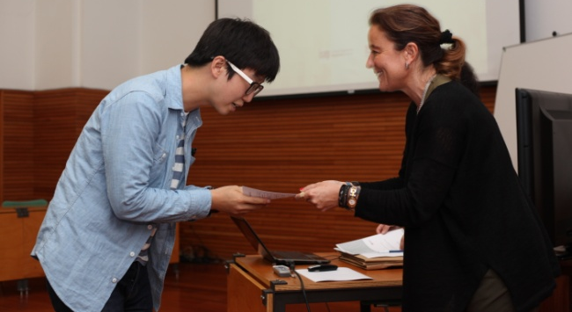
Figure 6. E4SD: Vice-President handing participation certificates.
In this session part, the Jury could also attribute the prize for the Best Group Work to Group nº 1 that was composed by only one Korean (as the other student had to return back home one week sooner due to health condition) and two Portuguese students (Figure 7).
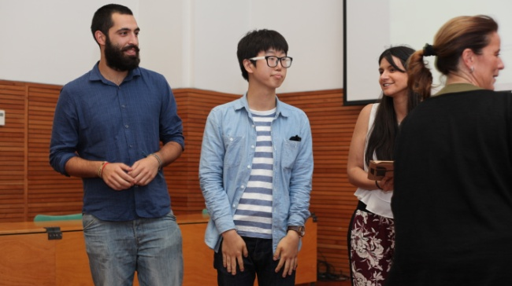
Figure 7. E4SD: Best group work award.
The session proceeded to the second part, the Closing session, in an informal setting with the attribution of the aComedy Awards, a set of funny awards related with their experience, for some categories that could be most suitable to some of the students, and that were very well received by them.
There was the reading of a Farewell poem originally composed by one of the teachers in the organizing team of E4SD (Figure 8).
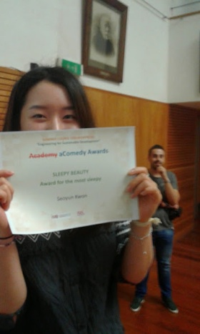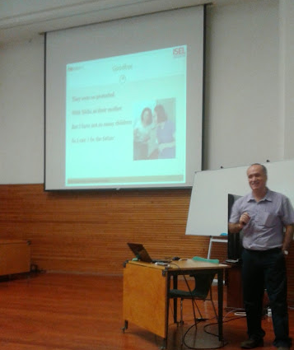
Figure 8. E4SD: Farewell session.
Finally the Korean students spontaneously decided to perform a Korean song dedicated to all the E4SD participants (Figure 9), in a very emotional session.
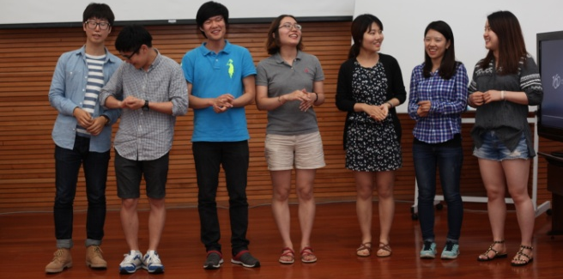
Figure 9. E4SD: A spontaneous expression of emotions.
After two intensive and informal weeks of education on the thematic of sustainability, students and teachers were ready for a new adventure and took a final photo (Figure 10).
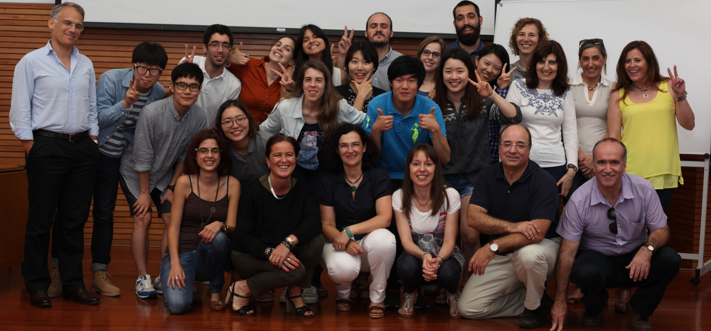
Figure 10. E4SD: The final picture.

E4SD EVALUATION
The course evaluation was done in a subjective and object mode. The items subject to evaluation include: Participants and graduate students; Professors and collaborators; Group work assessment and selection of the awarded one; Inquiry results and Availability of information in English in Academic/ Social Services. These will be described in the following sections.

Participants and graduated students
A total of eight Korean and eight Portuguese students were enrolled in the E4SD 2014 @ ISEP edition. Of these, one student had to return home sooner than expected, and therefore only attended to part of the sessions.
The students and professors developed an informal relationship along the whole course. In spite of the short duration of the course, a change in the attitude towards a more interactive participation of the Korean students in classes was noticed, which was promoted by the Portuguese participants and teachers.
At the end of the course, a total of fifteen students received their participation certificate.
A total of three students received a prize for their best results of the group work produced and presented. They integrated group nº 1, developed the theme Addressing transportation/mobility needs and standards in Historical Cities: Porto and their names are Geonhyoung Kim, Manuel Semedo and Maria Inês Barreto.
The Portuguese students decided, before knowing the results, to raffle their prize book among the other Korean students, in a very particular demonstration of affect and partnership towards Korean colleagues.

Professors and collaborators
Although there were some difficulties in communication with students (especially in the first days), everyone made an effort to understand and make themselves understood.
It should be noticed that the English skills of most of the Korean and part of the Portuguese students have been significantly improved throughout the course.
The classes on specific topics of sustainability applied to engineering occurred normally, and even a last minute change of a professor did not bring any drawbacks on the quality of the course, a demonstration of the team commitment towards this course.

Group work assessment and selection of the awarded one
The results of each group work were presented publicly before a Jury composed by two teachers that had participated in the course classes and one invited participant from another University. They took into account the quality of the oral presentation, the contents of the slides prepared, and the identification of the sustainability issues, as well as the proposed approach to solve the problem they had chosen to address.
Surprisingly, a large number of people attended to this session, in a clear demonstration of the institutional interest of this event.

Inquiry results
At the end of the course, a Questionnaire was passed to the students that finalized the E4SD. Also a Self-Evaluation form was provided for each student to evaluate their participation and results (Quadrado et al., 2013). The evaluation could be rated in six levels, respectively:
1 | Poor | 2 | Insufficient | 3 | Average | 4 | Good | 5 | Very Good | 6 | Excellent
None of the students rated any of the items as Poor.

Quality of Course Support
Globally the students rated the course support as Very Good or Excellent.
The Accommodation conditions was considered to have a few drawbacks – mainly the closing time was pointed out as not completely convenient. Students were staying in a students’ residence provided by the social academic services of IPP, occupying some rooms that were left free by national students who already had returned home. These kind of residences have a closing time by 23:30. After that, students must wake up the guard, as the doors are closed. Also they can receive visitors only until 22:00, in a common area outside the main building.
This global result was due to the collaboration of the Professors and Collaborators team, as well as to Portuguese students’ dedication to their new colleagues. The fact that there were four students coming from the same course of ISEP and that were used to participate in international activities was a factor that contributed to this integration. Also the other Portuguese students were anxious for participating in such an interesting course.

Course global evaluation
Globally the students rated the course as Very Good or Excellent, with a few answers also at the level of Good, mainly in what concerns to the PBL problem, which theme was not felt as really interesting for most of the Korean students, who believed that rebuilding from scratch is a much faster solution. Nevertheless, students admitted that the PBL approach was responsible for their ability to contextualize the engineering problem and the possible solutions and for the application of the knowledge about sustainability in this real life context. This has also been experienced by other students in engineering courses (Guerra and Holgaard, 2013). According to this group of students, PBL was responsible for their fast insight of the proposed problem, as they had to find the related information by themselves and could interact freely both in and out of the classroom.
Also about 1/3 of the students rated the Professors’ aptitudes as Good only.

Course Professors Exposition Skills Evaluation
Every Professor was evaluated for several items of their collaboration in the specific module that he had taught/participated. Most of the Professors were rated as Excellent or Very Good, but there were a few that were only rated below.

Theme and Module Content Evaluation
In what concerns the evaluation of each Theme and corresponding Module Content, Modules 7 (Sustainable Product Design) and 8 (Materials and Process for Sustainable Engineering) were the less exciting, even though globally all the modules were rated at least as Good.

Module Global Evaluation
For most of the modules the evaluation was almost evenly rated as Good/Very Good/Excellent. In fact Modules 1 (Engineering for a Sustainable Society), 2 (Decision Analysis for Sustainability) and 4 (Sustainability in Project Management) were rated as Excellent by half of the students.

Availability of information in English in Academic/Social Services
A problem that was identified by both the organizing committee and the incoming students, was the lack of information in English. In fact, most of the regulations, directions, rooms, laboratories and services’ labels are only in Portuguese, what makes it difficult for the non-Portuguese speaking visitors to understand.
The same problem was detected in the institutional intranet, that is prepared to dematerialize all the academic processes, but only in Portuguese.
In what concerns the students’ customer services, it was also noticed a lack of training of employees in order to pay a good service.

DISCUSSION
With a set of modules taught by experienced teachers in different topics of sustainability, the course had a problem based learning (PBL) approach and was organized in a very informal model. A total of 8 Korean and 8 Portuguese students from different areas of scientific knowledge attended this course and could interact and develop ties with each other and the teachers involved in the course, while learning and applying the fundamental skills on sustainability.
In what concerns the approach used by students from different countries to solve the sustainability problem that was launched for discussion (The Rehabilitation of Historic Cities - The Case of Porto UNESCO World Heritage Site: A Sustainable Development Challenge) it was noticed a clear difference between the two cultures. Whereas the young Korean students did not seem to care about the heritage behind a building or an historic city, the Portuguese students, used to live in a historic city, proposed a much more conservative approach. However, both the students could interact and understand the other side of the problem, reaching a consensual proposal. Finally the Korean students came to the conclusion that it was of interest to preserve Porto history. The fact that Korea is a very different country and that Korean culture is significantly different from the European one, could have triggered cultural issues. Nevertheless, the young generations are prone to change and adaptation to new situations, what allows for the resolution of any possible conflict.
The PBL approach allowed for a more dynamic and informal learning environment. This revealed attractive for the young Korean students who were gaining different skills in this Summer Course as a prize for their good results in their formal learning courses.
On the other hand, for the Portuguese teachers the E4SD Summer Course presented an opportunity to interact with a larger group of students with the same different culture, which is different from interacting with only one or two students coming from Europe under Erasmus mobility, in a very short and intensive contact period.
The team of Portuguese teachers enjoyed participating in this experience and found the PBL approach useful for some kind of learning matters and problems, even in the engineering area. Nevertheless, it must be stated that these teachers were chosen for their ability to communicate easily and to interact with people from many different fields of engineering and sciences, which makes them prone to new experiences.
The problems posed by the need for Professors’ replacement during the period of course classes were promptly solved by the team members of E4SD. The new Professors did not participate in most activities but, even so, they showed their availability to take part in future events of the same kind.
The Portuguese students, from different fields of engineering said that although they were a bit afraid of English communication difficulties, the experience had been very profitable and interesting and that it should be replicated, probably in an earlier stage and along the graduation.
All the team members were very happy with their participation and were willing to repeat this kind of event, with some more information that will allow them to reduce the effort to make of this E4SD a success. They are so looking forward for another similar challenging event.
The social activities allowed for the students’ fast integration and intercultural mix. Going to a music concert, to a football match or simply going on a night tour or preparing a meal including traditional food from student’s hometown facilitates interaction.
A prize was awarded to the Best Group Work: Addressing Transportation/Mobility Needs and Standards in Historical Cities: Porto. The opinion of the Jury members was unanimous saying that this work was the one that showed better the knowledge and skills that were supposed to be acquired through the course participation.

CONCLUSION
The E4SD 2014 Summer Course took place at ISEP from the 14th to the 25th July. Seven of the eight Korean and the eight Portuguese students finished successfully their participation in the Course.
There was a clear difference between the two cultures towards the same type of problems in what concerns sustainability. For the young Korean students the heritage behind a building or an historic city did not seem too important, whereas for the Portuguese students, used to live in a historic city, the proposed approach was much more conservative. Nevertheless, both the students could see the other side of the problem, and the Korean students finally understood the interest of preserving Porto history.
The E4SD allowed that students, the representatives of the next generation, having different perceptions of the problem could relate and reach a consensual solution. The fact that Korea is a very different country and that Korean culture is significantly different from the European one, could have triggered cultural issues. Nevertheless, the young generations are prone to change and adaptation to new situations, what allows for the resolution of any possible conflict.
As mentioned before, one of the main objectives of this course was to assess the real institutional ability to host international teaching initiatives, even from countries with substantially different culture. The results achieved were really encouraging as the experimentation of teaching at an international and intensive level was challenging and motivational.
In fact, PBL proved to be a way of promoting integration and the inclusion of multiple cultures allowed the analysis of different perspectives which otherwise would not have been considered. On the other hand, all the students lived an international experience in a non-native language, which has driven them out of their comfort zone, and teachers proved their ability to manage multicultural environment.
This experience showed that it should be replicated, possibly with students coming from other cultures, and was the seed for establishing a formal offer of graduation courses.
The result was very promising at pedagogical and institutional levels. A qualitative measure was obtained at the end of the farewell session, when both teachers and students became sad because of the end of the course.

ACKNOWLEDGMENTS
Our thanks to all of the teachers who participated in this Summer Course in Engineering for Sustainable Development (E4SD) and to the President of ISEP who allowed the organization of this unforgettable experience.

REFERENCES
Buckler, C. & Creech, H. (2014). Global Monitoring and Evaluation Report, Shaping the Future We Want – UN Decade of Education for Sustainable Development (2005-2014), UNESCO, Paris, France.
Encyclopædia Britannica (2015). Engineers' Council for Professional Development definition on Encyclopædia Britannica. Retrieved June 2015 from http://www.britannica.com/technology/engineering.
European Commission (2014). Erasmus – Facts, Figures & Trends. The European Union support for student and staff exchanges and university cooperation in 2012-13. Luxembourg: Publications Office of the European Union. doi:10.2766/76447. Retrieved November 2015 from http://ec.europa.eu/education/library/statistics/ay-12-13/facts-figures_en.pdf
Ferreira, J.M.M. (2015). Internal resistance to change: New teaching methods. In: 2nd International Seminar on Strategic Direction of Higher Education. ISEP, Porto, 23rd June (in Portuguese).
Green, T.L. (2013). Teaching (un)sustainability? University sustainability commitments and student experiences of introductory economics, Ecological Economics, 94, 135-142.
Guerra, A.O. & Holgaard, J.E. (2013). Student’s perspectives on Education for Sustainable Development in a problem based learning environment. In: Engineering Education for Sustainable Development, Cambridge, UK. September 22 – 25.
ISEP (2013). Relatório de Atividades do ISEP. ISEP – Instituto Superior de Engenharia do Porto. April 2014 (in Portuguese).
ISEP-DEI (2014). Retrieved November 2015 from http://erasmusdei-isep.blogspot.pt/
Labodová, A., Lapčík, V., Kodymová, J., Turjak, J. & Pivko, M. (2014). Sustainability teaching at VSB – Technical University of Ostrava, Journal of Cleaner Production, 62, 128-133.
Quadrado, J.C., Caetano, N.S. & Cardoso, J.M. (2014). E4SD: Engineering for Sustainable Development Course Report. ISEP, September 2014.
Rose, G., Ryan, K., Desha, C. (2015). Implementing a holistic process for embedding sustainability: a case study in first year engineering, Monash University, Australia, Journal of Cleaner Production, 106, 229-238.
Staniškis, J.K. & Eglė Katiliūtė, E. (2015). Complex evaluation of sustainability in engineering education: case & analysis, Journal of Cleaner Production, In press, http://dx.doi.org/10.1016/j.jclepro.2015.09.086.
Steinemann, A. (2003). Implementing sustainable development through problem-based learning: pedagogy and practice. J Prof Issues Eng Educ Pract 129:216–225.
Wood, D. F. (2003). Problem based learning. BMJ : British Medical Journal, 326(7384), 328–330.
World Commission on Environment and Development (1987). Our Common Future, Report of the World Commission on Environment and Development. Retrieved June 2015 from http://www.un-documents.net/wced-ocf.htm.

