The role of social networks in communication in the scientific research community

ABSTRACT

Social networks have grown rapidly in recent years, enabling the application of social web technologies to the scientific process and creating platforms that enhance communication between researchers. The aim of this research is to go one step further and investigate whether the use of more general social networks, such as Twitter or Facebook, is also becoming more widespread for scientific research, thus contributing to the visibility of scientists and their collaborative networks. Social media analysis is carried out using the Brandwatch platform to assess the use of generalist social networks in research, and compared with the use of scientific social networks through an online survey of university professors. The resulting conclusions show that scientific mentions in networks are rare and that, despite the importance of researchers having a profile in a social network, which allows them to give greater visibility to their results and receive feedback from their colleagues, many of them are still unaware of its usefulness.

KEYWORDS -
social network; scientific network; research; dissemination; communication.

1. Introduction

Social networks are in fashion, they are growing every year and society is clear about their use to be in contact with a multitude of people, to reflect moods, to share experiences, lifestyles and brands, ... These different uses make us wonder to what extent generalist social networks can be used in academic research.

According to the Digital 2023 Global Overview Report, the number of network users will grow by 227 million in 2021, reaching a total of 4.7 billion by early July 2022. The global number of active "user identities" on social networks will reach 4.8 billion by April 2023. Current trends suggest that by July 2023, two-thirds of the world's population will be online and the number of social network users will be equivalent to 60% of the world's population (Meltwater & We are Social, 2023).

In 2023, around 85% of Spanish internet users accessed social media platforms. In 2022, the country registered more than 40 million social media users, making it one of the largest social media markets in Western Europe (IAB Spain, 2023).On the other hand, according to a survey conducted in Spain by IAB Spain in March 2023 and reflected in Figure 1, WhatsApp was the favourite social media app for 32% of respondents. The messaging app has lost its position compared to the previous year, while TikTok and Instagram were the networks that grew the most in user preference since 2022.

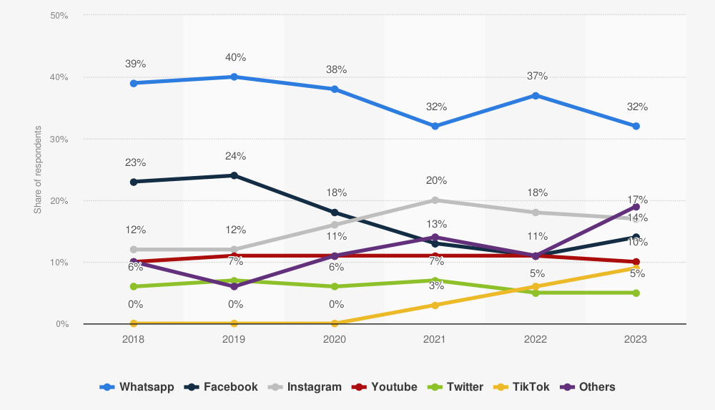
Figure 1. Most used social media platforms in Spain (from 2018 to 2023)

In terms of how people use social media, according to the Digital News Report 2023, people are now 2.5 times more likely to turn to social media for news than to print newspapers and magazines (Reuters Institute, 2023).

In short, it can be argued that social media is now more than just a means of communication, as it has evolved to create personal and social connections, as well as influencing business and politics. However, it should not be forgotten that researchers also interact and communicate to share results, projects, resources, information and documentation in scientific social networks (Zapata, 2011), which also helps them to communicate with other research colleagues. Therefore, the aim of this research is to find out whether, in addition to purely scientific social networks such as Research Gate or Methodspace, the most popular social networks are also used at the scientific level.

In its Recommendation on Open Science, the United Nations Educational, Scientific and Cultural Organisation (UNESCO) defines Open Science as an inclusive construct that brings together diverse movements and practices to make multilingual scientific knowledge openly available, accessible and reusable by all, to strengthen scientific collaboration and information sharing for the benefit of science and society, and to open up the processes of creation, evaluation and communication of scientific knowledge to societal actors beyond the traditional scientific community (UNESCO, 2021).

In this sense, all the possibilities of communication through the Internet allow the exchange of opinions and knowledge between students, teachers, specialists, etc., and should promote the development of scientific, creative and expressive skills, as well as the cultivation of positive attitudes towards interpersonal communication (Fox and Wilson, 2009). Therefore, in recent years, according to Nassi-Caló (2015), the use of social networks in scientific communication has increased, and specific platforms for interaction and information transfer between researchers have been created.These platforms are used in the same way as general networks, but only involve teachers, who usually participate in research projects.

Social networks are like virtual laboratories because they offer all the services that a research group needs: a simple communication system, the possibility of using different ways of sharing resources, the storage of documentation in a profile and the creation of discussion forums (Equihua, 2016).

Science 2.0 can be seen as the application of social web technologies to the scientific process. Codina (2009) highlights two basic ideas that favour the use of Web 2.0 in science: science is communication and science is collaboration. Communication and collaboration are the aspects to be highlighted in any social network, hence the importance of its use in research.

Social networks have also generated new metrics for measuring science, so the term altmetrics can be defined as an alternative metric that complements traditional metrics, insofar as it allows the counting of citations or mentions of global academic production to be fairer and more egalitarian, giving rise to a science that is also more democratic, since it is characterised by the creation and use of new indicators that explore the properties of measurements based on social networks, acting in the same way as traditional impact indicators 8Vanti and Sanz, 2015).

For this reason, it is now necessary for every researcher-teacher to have at least one profile in a scientific social network, which allows them to make their research activity known to the rest of their colleagues and improve its visibility, increasing the chances of being cited by other researchers in the same field.

The possibilities offered by a scientific social network are varied, but we must be participative and take into account the importance of both collaboration and participation, as it will also be useful for the scientist to receive feedback on his or her work (Santana, 2010).

With regard to generalist social networks, they can be considered as "associations of people linked by heterogeneous motives, forming a structure composed of nodes linked by more than one type of relationship" (Hernández, 2008: 30). In other words, there may be several reasons why several people are linked in this network, which is why it is more feasible to reach a larger number of people than just with a scientific social network where people are linked by scientific interests.

However, although these more generalist social networks are used on a massive scale, they are rarely used for scientific and/or didactic purposes, and in this sense there is still a long way to go to enable more efficient communication and collaboration between students and teachers/researchers, or even between researchers themselves.

The following table (Table 1) summarises the main advantages and disadvantages of the use of generalist social networks by researchers, and although it may seem that the advantages and disadvantages are close together, the disadvantages can be reduced, since in an environment as volatile as the one we live in, speed can be a reward, which should not compromise quality or thoroughness due to proximity, both of which become a virtue.

Table 1. Advantages and disadvantages of social networks for the scientific community

PROS OF SOCIAL MEDIA | CONS OF SOCIAL MEDIA
Immediate communication system  Registration at no financial cost  Facilitate interaction between users  Allow discussion and feedback  Connect people from any country.  Bring together colleagues of different scientific and academic status.  They allow research results to reach any profile.  A quick search for information | Speed of publication may be more important than quality  They generate competition among scientists to be pioneers in disseminating information.  They can spread hoaxes or "fake news".  Giving more importance to the result of the research than to other aspects.  Bringing science closer to society can make the information less rigorous.  Possible lack of respect in the absence of moderators.  Transfer of users' personal data in exchange for advertising.

Source: Fernández Bayo et al., 2019

Furthermore, it should be pointed out that the analysis of social networks is a complex and rigorous process that requires knowing how to identify false information, any type of publicity or negative effects that may affect the final results of the proposed research, but also knowing how the platform to be used for this analysis works.

In view of this, the main objective of this research is to discover the use of generalist social networks at the scientific level and the level of development of scientific networks, for which it aims to answer the following questions

1. Are generalist social networks used in research?
2. Among the generalist social networks, which are the most used for the dissemination of science?
3. Do researchers know about scientific networks, how do they perceive them and how do they use them?

2. Methodology

The methodology of the proposed research is based on the study of general social networks in what is known as social listening, originally a practice of monitoring what customers say about a brand in different online spaces. Social listening works not only with the perception that users have on networks about a specific brand, but in general at any point of online contact between the consumer and the brand.

Most social media data is stored in a structured or unstructured format. Structured data adheres to standardised and well-defined data formats, while unstructured data is often more difficult to process because the format is not predefined, such as a Facebook post (Hartman 2020). A variety of social technologies can be used to analyse this data: 'social listening platforms', 'social advertising technology' and 'social suites'. Social listening platforms are used to collect, manage and analyse social media data. Social advertising technology is used to manage and measure social media advertising. Social suites combine many of the capabilities of social technologies into a single platform. They are used to perform tasks such as data collection and analysis, and publishing customer communications (Liu and Dawson, 2021).

According to the report, "Forrester Wave: Social Listening Platforms ™ (SLP), Q4 2020', which provides a comprehensive assessment of the leading SLP vendors, Brandwatch, the consumer research platform used in this research, which was assessed alongside nine other SLP vendors (Digimind, Linkfuence, ListenFirst, Meltwater, NetBase, Quid, Sprinklr, Synthesio, Talkwalker, and Zignal Labs), is a leader in the platform market, scoring highest in the areas of strategy and market presence (Liu and Dawson, 2020).

The process of social media analysis is typically divided into four phases (Stieglitz et al., 2018):
- Discovery: identification of content and its corresponding keywords, hashtags, etc., which contribute to defining the objectives of the analysis and the main hypotheses to be tested.
- Monitoring: identifying data sources and data collection.
- Preparation: Prepare the data for the subsequent analysis.
- Analysis: Applying various analytical methods and techniques to the data set prepared to answer the questions posed in the discovery phase.

In this research, as shown in Figure 2, the same steps proposed by Stieglitz are followed, with the addition of another step related to subsequent implementation, understood as the need to effectively communicate the results of social network analysis.

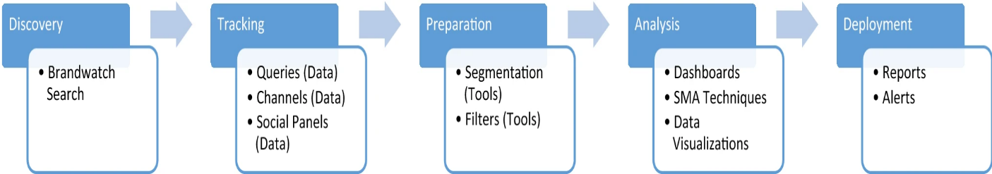

Figure 2. Mapping of Brandwatch's key functions to the network analysis process framework

The discovery phase uses Brandwatch Search, an artificial intelligence-based search engine that uses sophisticated natural language processing techniques. In this case, the search is linked to the use of social networks in research. In the follow-up phase, the so-called query is formed, which refers to the set of words that allow information to be obtained from the platform's systems. For this purpose, Boolean operators were used to combine the searched concepts and to refine the results to be obtained, as shown below:

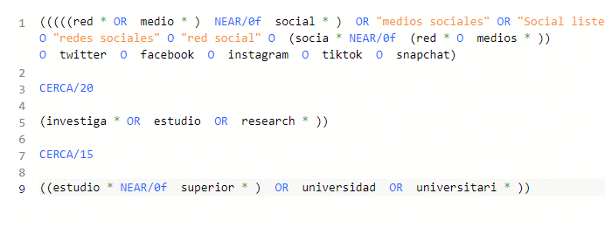

This query returns 3,980 mentions in the last 30 days on the day of the study alone, after filtering by language (Spanish), but searching all over the world. Therefore, tools are needed to segment and filter this information, including a test preview to immediately evaluate the type of mentions retrieved from the current query logic, favouring the intended social analysis; in this search, it was decided to eliminate websites that mention the terms searched for but are not related to the objective of the study.

Finally, the query is maintained, filtered by language, invalid sites are eliminated and a date range of one year is marked in order to analyse whether the evolution of the content under study follows a certain pattern.

In the last two stages, the results obtained are analysed and acted upon through the use of dashboards, which monitor and visualise the key indicators.

This network analysis is based on a sampling rate of 100%, with an estimated 3,314 mentions per month.

This study was contrasted with a short survey, using a Google Forms form, of researchers and professors at a university in Madrid, guaranteeing the anonymity of the responses obtained, which made it possible to compare the evolution of the researchers' own networks and their perceptions of them with the results obtained through social listening. The questionnaire consisted of ten simple questions, mostly dichotomous and some with a Likert scale to measure the degree of agreement or disagreement, with an estimated average response time of eight minutes. It was conducted between mid-May and June 2023, with a total of 148 responses. The link to the survey is: https://bit.ly/44JeHMN

3. Analysis and results

The results derived from the social listening research, shown in Figure 3, show little volatility, as only on 22 November and now are there more mentions in networks about the use of networks in research, reaching 800 and 1000 mentions/day respectively, with an average of 100 mentions per day. However, this figure is very low if we compare it, for example, with the number of mentions on the same dates of the query on the use of artificial intelligence in research and higher education, which reached 19,962 mentions, with peaks on some days of up to 3,047 mentions/day.

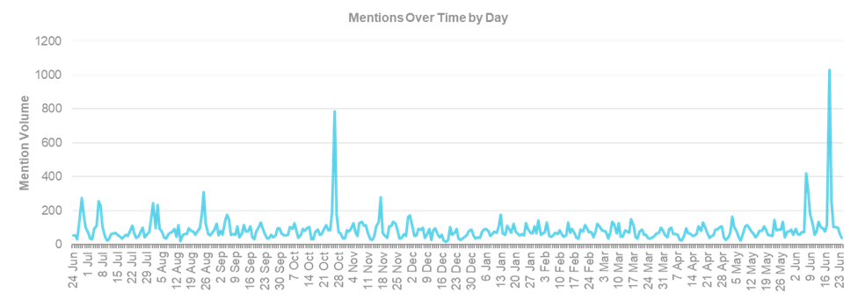
Figure 3. The volume of mentions by day

Next (Figure 4), we analysed which sources are leading this social conversation, showing that the social network Twitter clearly leads the volume of conversations about the search, with more than 100 days in the 12 months analysed in this research.

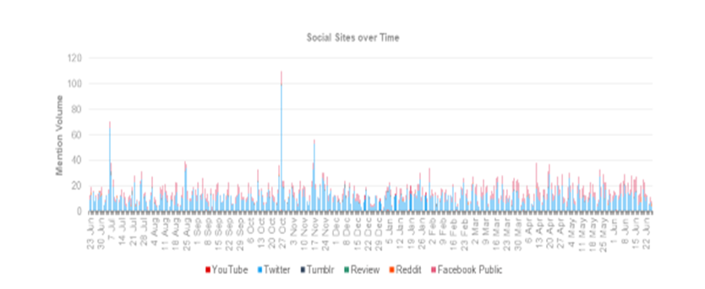
Figure 4. Media with the highest number of mentions per day

Figure 5 shows the trending topics related to the query studied, i.e. the number of mentions of the terms related to the study; the aim is to be able to deduce which keywords are driving these conversations, in order to better understand what underlies each conversation. In this way, we have chosen to use word cloud technology, which not only extracts the keywords in the conversations, but also identifies those with an increasing trend on the right-hand side of the lower horizontal axis, as opposed to those with a decreasing trend on the left-hand side of the same lower horizontal axis, with terms such as email, projects, information or person appearing, but without there being some more important than others, which manage to group together almost all the trending topics and which could be similar to the keywords listed for this work.

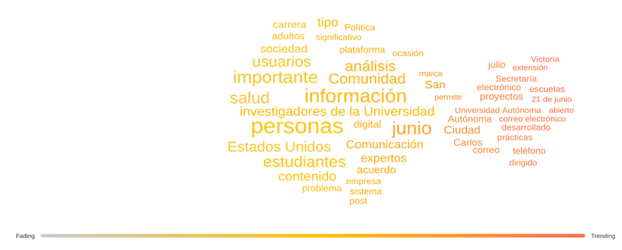
Figure 5. Trend topics

Figure 6 shows the top themes or most repeated mentions in the year studied, highlighting terms such as 'people', 'analysis' or 'information', which also appeared as trend themes.
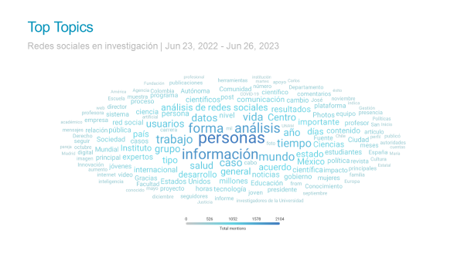
Figure 6. Top themes
It should be noted that in order to get a complete picture of the impact that online conversations on networks and the Internet have had over the last year, it is also extremely important to consider the feelings that they have generated. The fact that the topics analysed are relevant does not mean that they have been well received by the public or that they have generated feelings, i.e. whether the reaction in terms of sentiment analysis was positive, neutral or negative in relation to these topics, according to the Natural Language Processing (NLP) techniques used by Brandwatch.

Table 2 shows the ten sites that generated the most mentions in terms of the use of social networks in the research area during the last week under study, with a total of 578 mentions out of the estimated total of 3,314 mentions per month recorded for this analysis, meaning that these ten sites, with Twitter at the top, cover 69.76% of the total number of mentions.

The third, fourth and fifth columns quantitatively reflect sentiment analysis, also known as opinion mining, while the seventh column models the average impact of mentions on a logarithmic scale calculated by Brandwatch from zero to one hundred. In this case, it is worth noting that while Twitter generates the most mentions, it has the lowest impact, while yahoo.com is able to generate the highest level of impact with a remarkable 95.8 out of 100, suggesting that a generalist social network such as Twitter may generate the highest volume of mentions, but has a negligible impact due to its non-specialist nature in the scientific research field. On the other hand, yahoo.com is able to generate an impact six times greater, with only 30.9% of the mentions occurring on Twitter. Finally, the same is true for the last column, which reflects reach or the number of total views, where yahoo.com again dominates with the highest value in this section.

Table 2. Sites with the highest number of mentions and sentiment.
Site | Volume | Positive | Neutral | Negative | Monthly Visitors | Impact | Reach
twitter | 142 | 31 | 84 | 27 | 21.000 | 16 | 12
vnexplorer.net | 98 | 9 | 60 | 29 | 0 | 0 | 0
eldiario.es | 61 | 9 | 47 | 5 | 9.600.000 | 39,3 | 2701
headtopics.com | 57 | 9 | 44 | 4 | 0 | 0 | 0
flipr.com.ar | 52 | 2 | 29 | 21 | 0 | 0 | 0
yahoo.com | 44 | 5 | 27 | 12 | 1.873.020.000 | 95,8 | 4978
elpais.com | 39 | 4 | 28 | 7 | 48.427.000 | 45 | 4278
infobae.com | 39 | 4 | 27 | 8 | 16.937.000 | 43 | 3373
abc.es | 23 | 1 | 16 | 6 | 15.848.000 | 42,9 | 3300
elpopular.pe | 23 | 0 | 18 | 5 | 955.000 | 30,8 | 523

Notes: Average monthly estimates of 3,314 mentions are used.

After carrying out a descriptive analysis of the variables used for the sites with the highest number of mentions, and according to the statistics in Table 3, it can be clearly seen that the aforementioned variables have asymmetric frequency distributions, i.e. with a greater concentration of values below the mean, with the exception of reach, so that the median is better than the mean to describe the central tendency of the distribution of the data.

In any case, since the coefficient of skewness is positive, the distribution of all the variables is positively asymmetric, as they are all leptokurtic, i.e. they have a high degree of concentration around the central values of the variable, except for the variable negative sentiment and reach, which are platykurtic because their coefficient of kurtosis is negative.

Table 3. Descriptive statistics
 | Volume | Positive | Neutral | Negative | Monthly Visitors | Impact | Reach
Stocking | 57,8 | 7,4 | 38 | 12,4 | 196480800 | 31,28 | 1916,5
Typical error | 11,58044 | 2,825283 | 6,686636756 | 3,041199 | 186342968 | 9,343326 | 634,107
median | debajo | 4,5 | 28,5 | 7,5 | 5277500 | 35,05 | 1612
fashion | 39 | 9 | 27 | 5 | 0 | 0 | 0
Standard deviation | 36,62058 | 8,934328 | 21,14500204 | 9,617114 | 589268203 | 29,54619 | 2005,222
Sample variance | 1341,067 | 79,82222 | 447,1111111 | 92,48889 | 3,472E+17 | 872,9773 | 4020917
Kurtosis | 2,468201 | 6,486814 | 1,293885888 | -0,74893 | 9,9819878 | 1,483678 | -1,84339
Asymmetry coefficcient | 1,588092 | 2,383623 | 1,26178951 | 1,001601 | 3,1584425 | 0,966443 | 0,298925
Rank | 119 | 31 | 68 | 25 | 1,873E+09 | 95,8 | 4978
Minimal | 23 | 0 | 16 | 4 | 0 | 0 | 0
Maximum | 142 | 31 | 84 | 29 | 1,873E+09 | 95,8 | 4978
Sum | 578 | 74 | 380 | 124 | 1,965E+09 | 312,8 | 19165
Account | 10 | 10 | 10 | 10 | 10 | 10 | 10

As far as the correlation matrix is concerned, according to Table 4, it is shown with each variable in both rows and columns and the correlation coefficient in each cell. It can be seen that there is a perfect positive correlation between the variables related to emotions, while there is a perfect negative correlation between the variable’s visitors, impact and reach and the emotions themselves.

These results show an extreme dependence on the sentiment generated and the volume of mentions, which is to be expected as sentiment analysis depends on the natural language processing analysis performed on the mentions themselves. The correlation between reach and impact is also moderately strong with a positive value of 0.89, and between impact, reach and visitors with 0.77 and 0.55 respectively.

As the remaining correlations are non-existent (very weak), it can be concluded that these variables depend on other variables not included in the analysis offered by Brandwatch.
Table 4. Correlation Matrix between variables
 | Volume | Positive | Neutral | Negative | Monthly Visitors | Impact | Reach (new)
Volume | 1
Positive | 0,926366677 | 1
Neutral | 0,981765225 | 0,929276 | 1
Negative | 0,788665402 | 0,555281 | 0,676434303 | 1
Monthly Visitors | -0,142259388 | -0,10152 | -0,192206645 | -0,02479 | 1
Impact | -0,417770133 | -0,24881 | -0,43517556 | -0,40285 | 0,7783912 | 1
Reach (new) | -0,508286092 | -0,36186 | -0,50534079 | -0,48822 | 0,5549253 | 0,898278 | 1

Concerning the sentiment generated among the population by the use of social networks in research, as can be seen in figure 7, it is striking that it is eminently neutral, i.e. the NLP algorithm shows that although financial education about bitcoin and cryptocurrencies has indeed generated a relevant and growing conversation, the sentiment of the audience is mostly neutral with a total percentage of 73%. Despite the potential relevance of bitcoin and cryptocurrencies, the sentiment of the audience was mostly neutral with a total percentage of 73.98%, which would indicate indifference or an indication that this type of conversation would decrease despite the potential relevance. Positive sentiment followed with 6.56%, while negative sentiment came last with 19.45%.

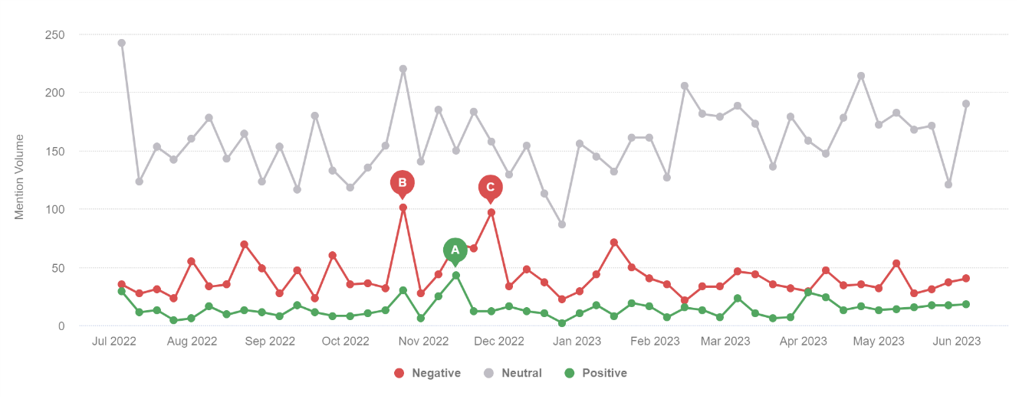
Figure 7. Evolution of sentiment

Figure 7 also shows that two peaks of sentiment activity have been reached in the conversations. It should be noted that reach is measured by the number of users who have seen a given publication at least once, so if a person sees a publication twice, the reach would be one, while the impressions would be two.

Specifically, 24 October and 28 November 2022 were the days with the highest negative sentiment, with a reach of 101 and 97 mentions respectively, although the first of these days was also the day with the highest neutral sentiment, with 220 mentions, and a record number of positive mentions (30), which continued to grow until reaching a peak of 43 on 14 November. To sum up, we can say that the months of October and November saw movement in the networks on the subject under study, generating different types of sentiment, with peaks.

In addition to the sentiment generated by the online publications during the period studied, it is important to know its evolution over these twelve months thanks to figure 8, where we can see that the trend of each sentiment only continues to grow in the same direction, thus strengthening each sentiment, since the neutral sentiment starts from 67 mentions and grows by 11.478%, the negative sentiment starts from 11 mentions and grows by 18.445% and finally the positive growth, which starts from 3 mentions and nevertheless experiences a growth of 22.833%, slightly higher than the negative sentiment. 445% and, finally, the positive growth, which starts from 3 mentions and nevertheless experiences a growth of 22.833%, slightly higher than the negative sentiment, which means that the changes in the perception of the conversations centred on the use of social networks in research are undergoing major changes in terms of the sentiment generated in the audience and the perception of the term studied is beginning to change.

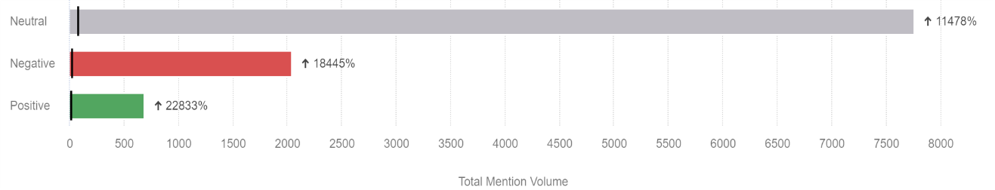

Figure 8. Social network sentiments of the surveyed group.

With regard to the survey carried out on a group of 148 teachers and researchers of different academic categories at a university in Madrid, it should be noted that the average age of the respondents to the survey was 44.6 years, and in most cases (93%) they were collaborating teachers.

The teachers were asked about their use of the specific networks Research Gate, LinkedIn and Academia.Edu. In most cases, 96.4% use only LinkedIn, 41.7% use Research Gate and only 23.4% use Academia. Edu.

When asked about their knowledge of these networks, the majority said they were aware of LinkedIn, but not of the existence of the other two networks surveyed, as only 52.3% said they had heard of Research Gate and 29.8% of Academia. Edu, the vast majority of respondents said that they had learned of its existence through the numerous banners that frequently appeared in their searches.

As for the possibility of uploading their research to more general networks, such as Twitter or Facebook, 87.3% said that they did not do so, perhaps because of the association with a subject other than academic research.

The results of this small survey are consistent with others previously carried out in other universities, such as the one carried out in 2015 among teaching and research staff at three Galician universities, in which 463 teachers responded. The highest percentage stated that they use professional LinkedIn (67.17%), followed by the academic Research Gate (61.34%) and Academia.edu (30.67%). 55.5% of the respondents consider LinkedIn easy to use, compared to 43.2% for Research Gate, while 44.3% of the respondents claim not to know how to use Academia.edu (Campos-Freire, & Rúas-Araújo, 2016).

Similar results were obtained by Said Hung, when he developed the so-called Cartilla didáctica, oriented to show the results related to the use of social networks by 487 researchers from different public institutions in Spain, within the Comscienciaeduspain project. The results of this study show that 3.7 out of 10 researchers have a very low, low or medium perception of the importance of social networks for the transmission of scientific knowledge, often due to lack of time or disinterest (Said Hung, 2022).

4. Discussion and conclusions

Social networks have become an important means of communication and academics and scientists should not shy away from participating in them. These more generalist networks would allow them to share their resources and results and create a network of collaboration between researchers in the same field. However, they can also make use of scientific networks whose sole objective is to make their own research known and to follow or be followed by other researchers.

Despite the existence of both types of networks, the qualitative research carried out with social listening and the quantitative research carried out with the analysis of an online survey of a sample of university professors, it can be affirmed that researchers still do not consider the more general social networks as a common way of transmitting their results.

In most cases, the use of academic social networks may be due more to an obligation on the part of the university to which they are affiliated, which may require the publication of scientific findings in this type of network for its own publicity, than to the interest of the researcher, who often doubts that these networks contribute to improving their scientific visibility, citations and research reputation.

A training effort is therefore needed on the part of university institutions to help improve the use of any type of more or less scientific network among researchers while recognising that the mere fact of publishing a scientific finding on social networks is not enough, but that active publications, participation in forums, etc., are also needed to keep the subject topical.

Only time will tell whether this form of communication, which is so deeply rooted in society, will become a means of communicating new scientific knowledge.

5. Funding

There is no funding for this research.

Referencias
Campos-Freire, F., & Rúas-Araújo, J. (2016). Uso de las redes sociales digitales profesionales y científicas: el caso de las 3 universidades gallegas. Profesional De La información, 25(3), 431–440. https://doi.org/10.3145/epi.2016.may.13
Codina, L. (2009). Ciencia 2.0: Redes sociales y aplicaciones en línea para académicos. Hipertext.net, 7, 295.
Equihua (2016). Redes sociales de investigación. Infotecarios. (Blog). https://bit.ly/1V3c5zj.
Fernández Bayo, I.; Menéndez, O.; Fuertes, J.; Milán, M. y Mecha, R. (2019). La Comunidad Científica ante las Redes Sociales. Guía de Actuación para Divulgar Ciencia a través de ellas, Universidad Complutense de Madrid. https://bit.ly/42YUIIF
Fox, A. & Wilson, E. (2009). Support our networking and help us belong!: listening to beginning secondary school science teachers. Teachers and Teaching: theory and practice, 15(6), 701-718. 10.1080/13540600903357025
Hartman, K. (2020). The day the geeks took over & storytelling with data. In Digital marketing analytics: In theory and in practice, 2nd ed., Ostmen Bennettsbridge Publishing Services, 2–38 and 161–216.
Hernández Requena, S. (2008). El modelo constructivista con las nuevas tecnologías: aplicado en el proceso de aprendizaje. RUSC. Revista de Universidad y Sociedad del Conocimiento (5), 2, 26-35.
IAB Spain. (May 10, 2023). Social network penetration in Spain from 2010 to 2023 [Graph]. In Statista. Retrieved June 17, 2023. https://bit.ly/43VTOOs
IAB Spain. (May 10, 2023). Favorite social media platforms in Spain in from 2018 to 2023 [Graph]. In Statista. Retrieved June 17, 2023. https://bit.ly/3Pvdc09
DataReportal, & We Are Social, & Meltwater. (January 31, 2023). Most popular reasons for internet users in Spain to use social media as of 3rd quarter 2022 [Graph]. In Statista. Retrieved June 17, 2023. https://bit.ly/46zJ3TN
Liu, Jessica, & Dawson, Sarah. 2020. The Forrester wave™: Social Listening Platforms, Q4 2020. Forrester Research Inc., November, 10, 2020
Liu, J. & Dawson, S. (2021). The Social Technology Convergence Stalls Out. Forrester Research Inc.
McGuirk, M. Realización de análisis de redes sociales con Brandwatch para Classrooms: una revisión de la plataforma. J Market Anal, 9 , 363–378. https://doi.org/10.1057/s41270-021-00128-5
Meltwater & We are Social (2022). DIGITAL 2022: Global Overview Report.
Nassi Calò, L. (2015). Estudio analiza el uso de las redes sociales en la evaluación del impacto científico. En SciELO en Perspectiva. Recuperado de https://bit.ly/2Z6dMV0.
Organización de las Naciones Unidas para la Educación, la Ciencia y la Cultura (UNESCO, 2021). Recomendación de la UNESCO sobre la Ciencia Abierta. https://unesdoc.unesco.org/ark:/48223/pf0000379949_spa
Reuters Institute (2023). Digital News Report 2023. https://bit.ly/3JxToWm
Said Hung, E. (2022). Uso de las redes sociales por investigadores en España. figshare. Proyecto (FCT - 20 - 15761) FECYT. https://doi.org/10.6084/m9.figshare.19736041.v4
Santana Arroyo, S. (2010). Redes de intercambio de información científica y académica entre los profesionales en el contexto de la Web 2.0. ACIMED, 21(3),321-333. https://bit.ly/3NteINX
Stieglitz, S.;Mirbabaie , M.; Ross, B. and Neuberger, C. (2018). Social media analytics—Challenges in topic discovery, data collection, and data preparation. International Journal of Information Management, 39, 156–168. https://doi.org/10.1016/j.ijinfomgt.2017.12.002.
Vanti, N. & Sanz Casado, E. (2015) La Altmetría como una opción para medir la ciencia de manera más justa y equitativa. In Desafíos y oportunidades de las Ciencias de la Información y la Documentación en la era digital: actas del VII Encuentro Ibérico EDICIC 2015 (Madrid, 16 y 17 de noviembre de 2015). Universidad Complutense de Madrid, Madrid
Zapata-Ros, M.(2011). La investigación y la edición científica en la web social: La ciencia compartida. RED. Revista de Educación a Distancia, 3(1),1-19. https://bit.ly/42Sqo2g

